

American International University- Bangladesh

CSC 3222: Web Technologies

CO1.1 and CO2.1 Evaluation

Project Report

Fall/Spring/Summer20-21

Project Title:Hospital Management System

Section: B

Group: 2

|  |  |
| --- | --- |
| Student Name | Student Id |
| SHARAIN ISLAM ANOY | 17-34184-1 |
| ALVEE MASHRUR KHAN | 18-37210-1 |
| HASIF IQBAL TANVIR | 16-31410-1 |
| MOSAEB BIN MOZIB | 18-38598-2 |

**Introduction:**

Now a days everything is going to be modern & digitalized. So, why not the health sector ? Health service is very important basic demand for human being. But unfortunately, due to over population, traffic jam, time complexity, modern life style it is becoming very difficult to get health service day by day. That’s why our project is about a health care system management.

In this project we are going to show a simple health organization website interface model that will be very easy to access & useful for general people & also any health sector organization.

**Background Study:**

References website: <https://www.lifespringint.com/>

This is a Bangladeshi Health organization website that becomes popular from 2020. We are doing this project by inspired this site. It’s an authentic reliable and very useful website for our modern people. People can get the service from this site having an internet connection only. In this site user can get details information about their services and policy, schedule and also take an appointment of doctor.

**Requirement Analysis:**

1. **User Category:**

Hospital management system is introduced with a convenient cause for helping hospitals to speed up their current process.

* There are 4 types of Users here. They are:
* Admin
* Doctor
* Patient
* Stuff

1. **Feature List:**

In this project the “Admin” has the following features:

* Add doctor.
* Add nurse.
* Doctor schedule.
* Nurse Schedule.
* Delete doctor/ nurse.

In this project the “Doctor” has the following features:

* Make a prescription.
* Access the test.
* See duty schedule.

In this project the “Patient” has the following features:

* See doctors schedule.
* Check medical test cost.
* See doctor availability.
* Take doctor’s appointment.

**Design:**

The entity diagram of **“Hospital Management System”.**

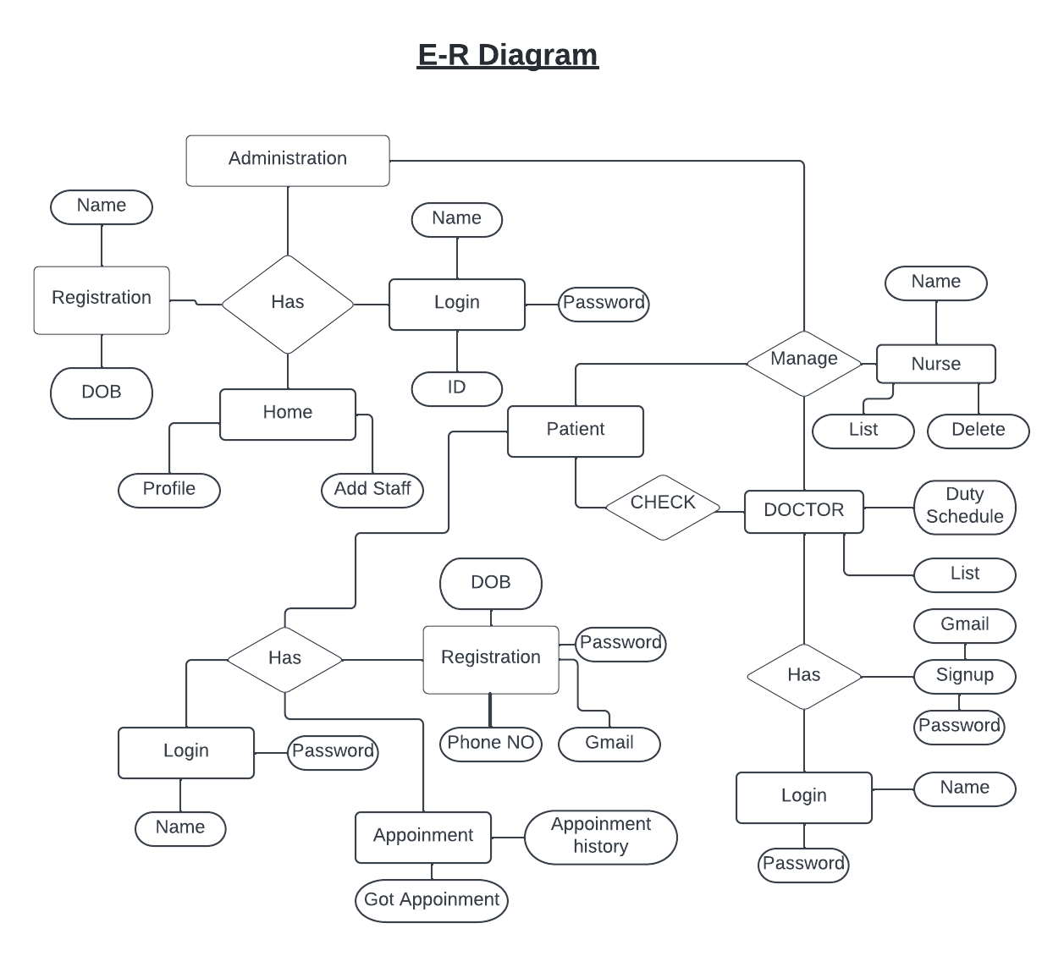

**Tools Used:**

To develop this project, we have used the following:

* Xampp
* Sublime text/ Notepad ++
* Browser
* HTML
* JSON
* PHP

**System Images against the Specification:**

**1. Admin:**

* **Add doctor:** All the necessary information of the doctor is taken here. Such as name, email, specialty, schedule, user name, password, confirm password, date of birth & gender.

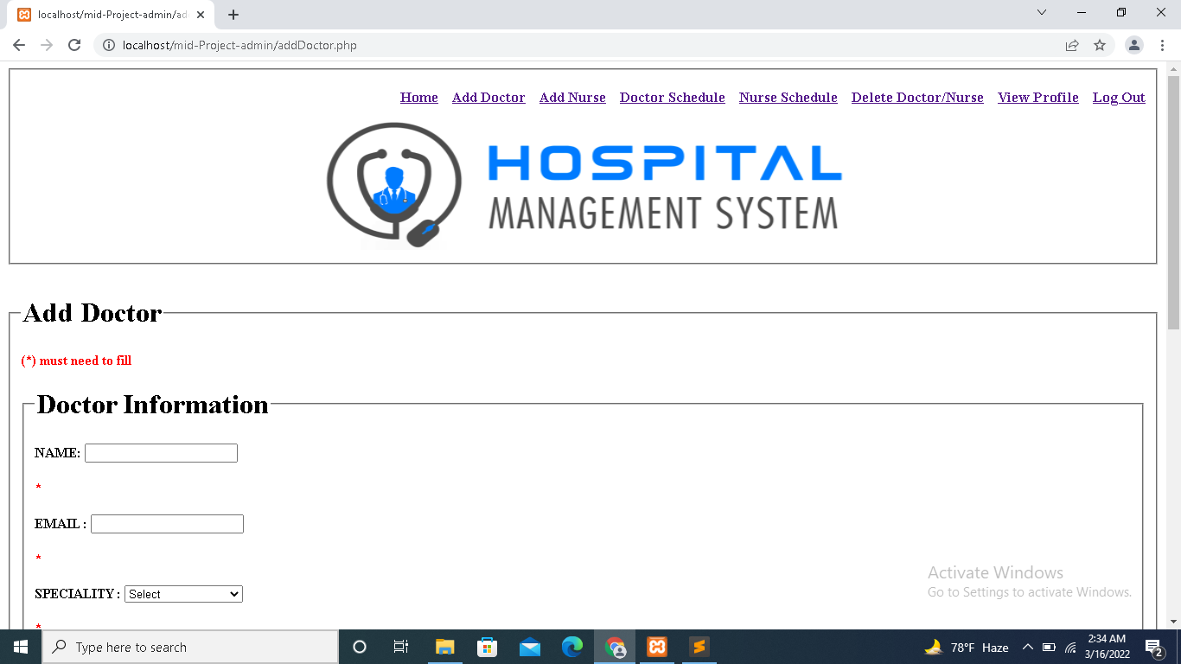

* **Add nurse:** All the necessary information of the doctor is taken here. Such as name, email, schedule, user name, password, confirm password, date of birth & gender.

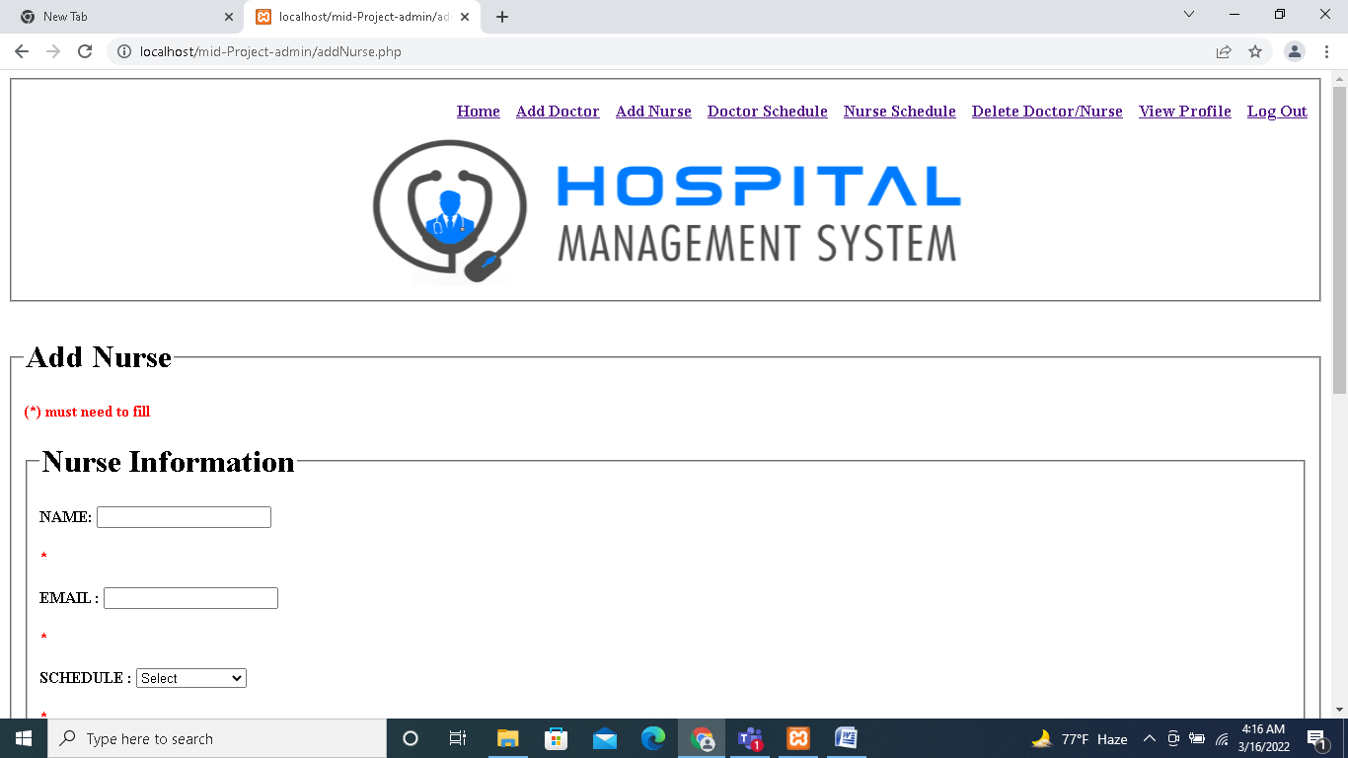

* **Doctor Schedule:** Doctor’s details are stored here.

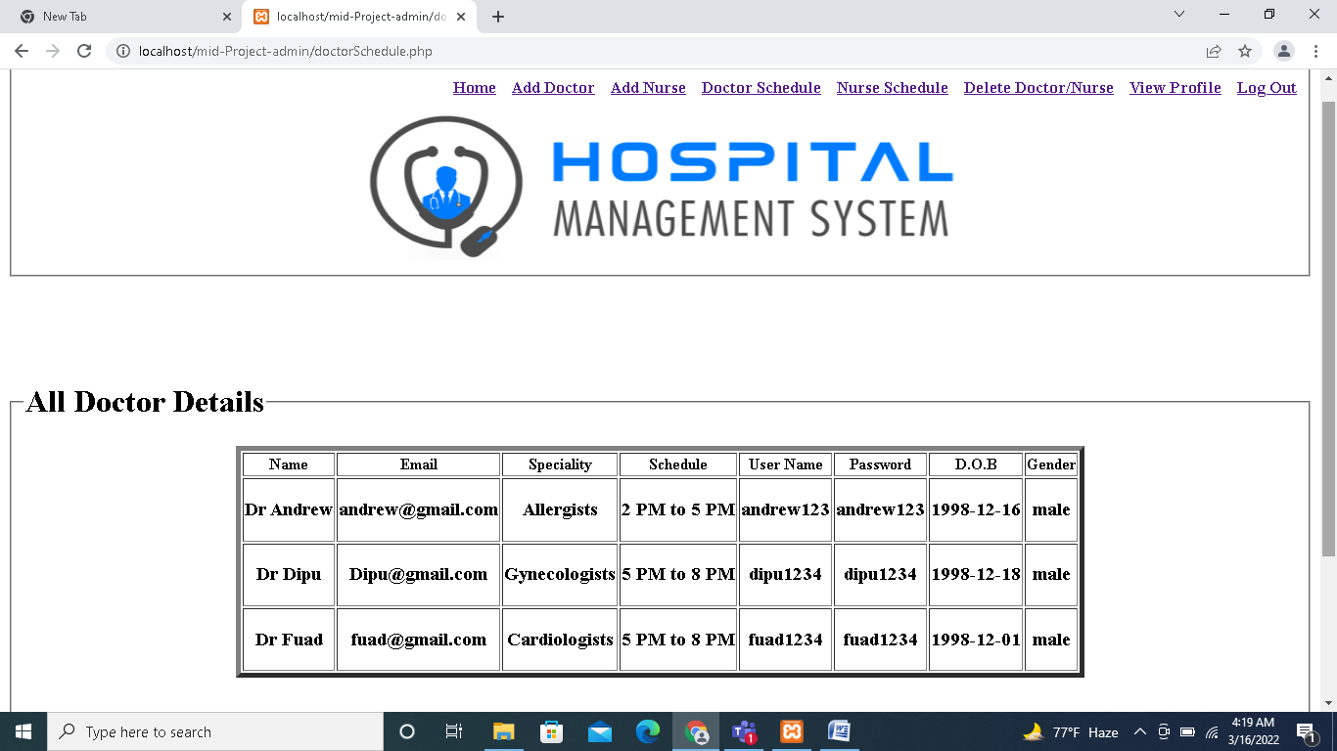

* **Nurse schedule:** Nurse’s details are stored here.

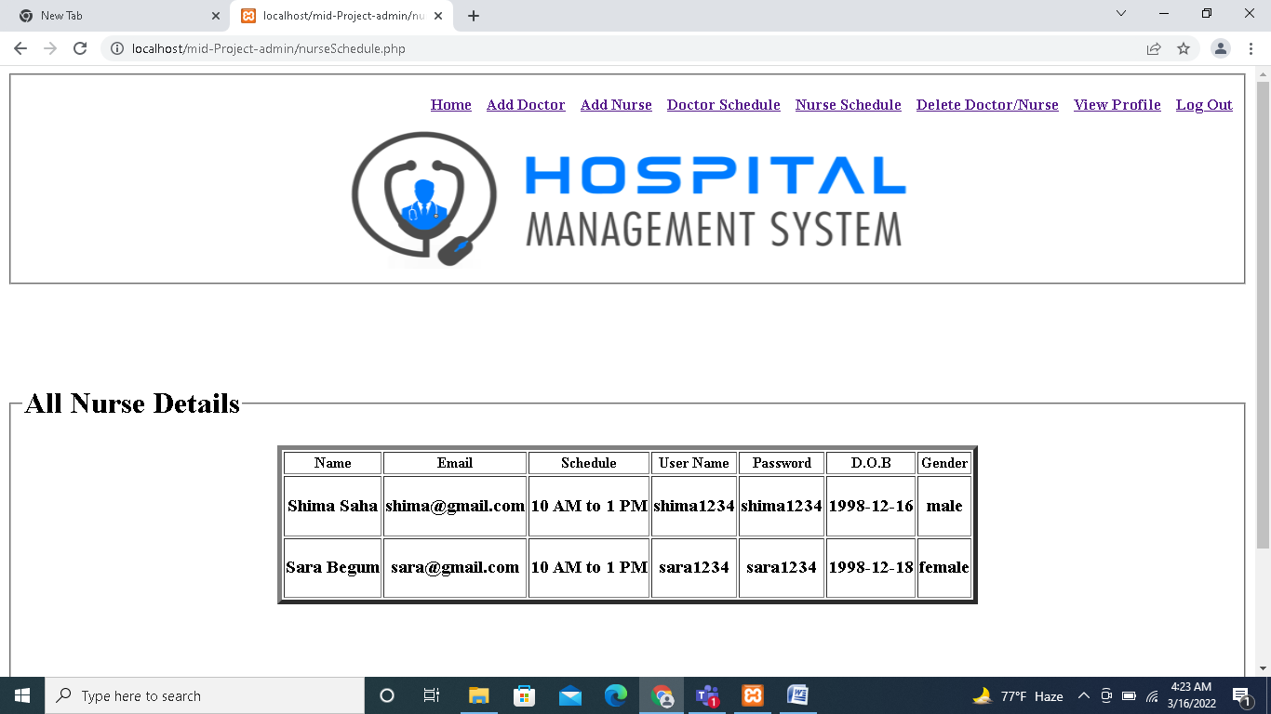

* **Delete doctor/nurse:** Delete by using email.

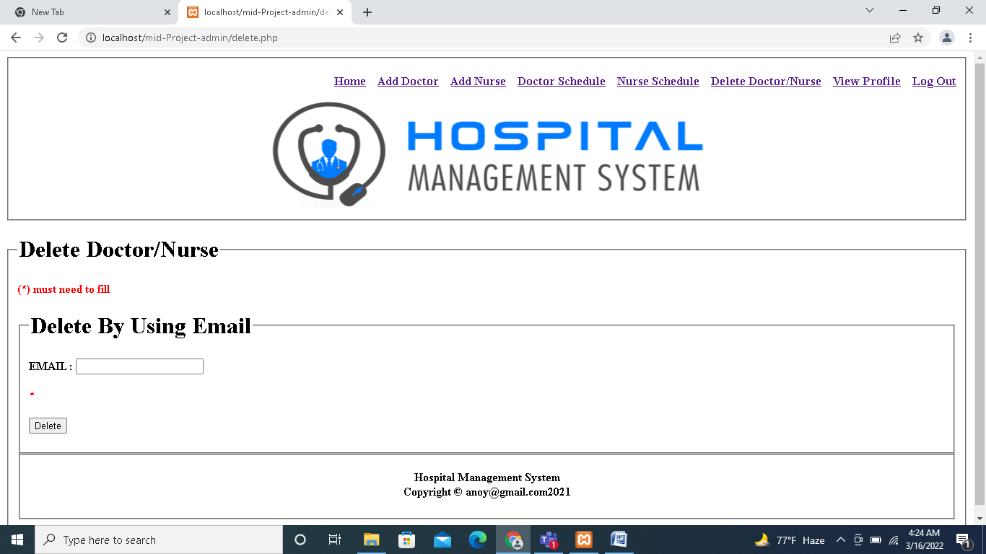

**2. Doctor:**

**3. Patient:**

* **Edit profile information:**

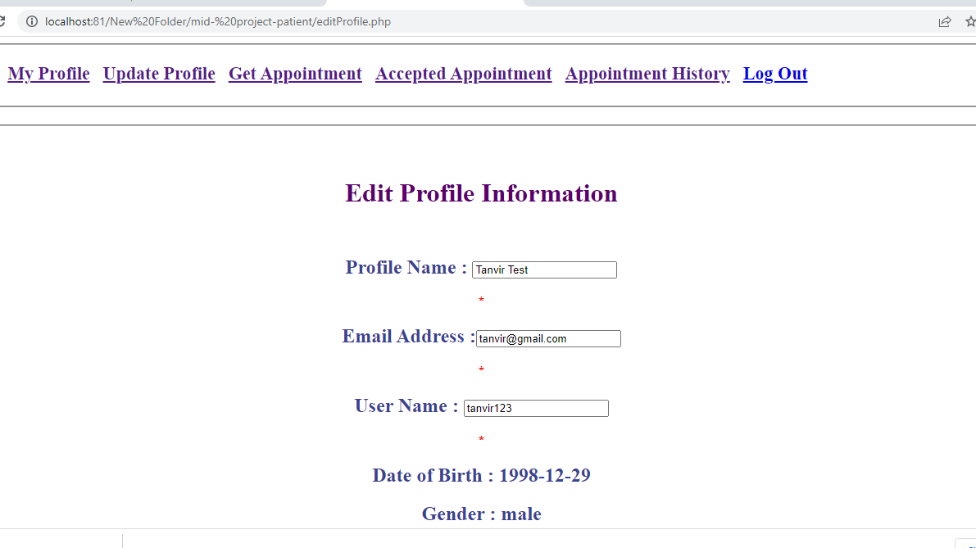

* **Update Profile:**

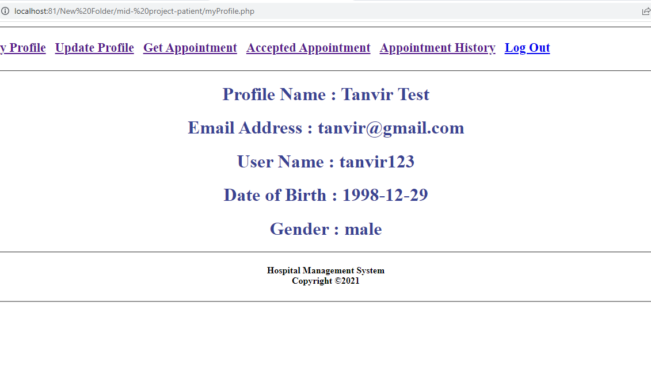

* **Doctor appointment:**

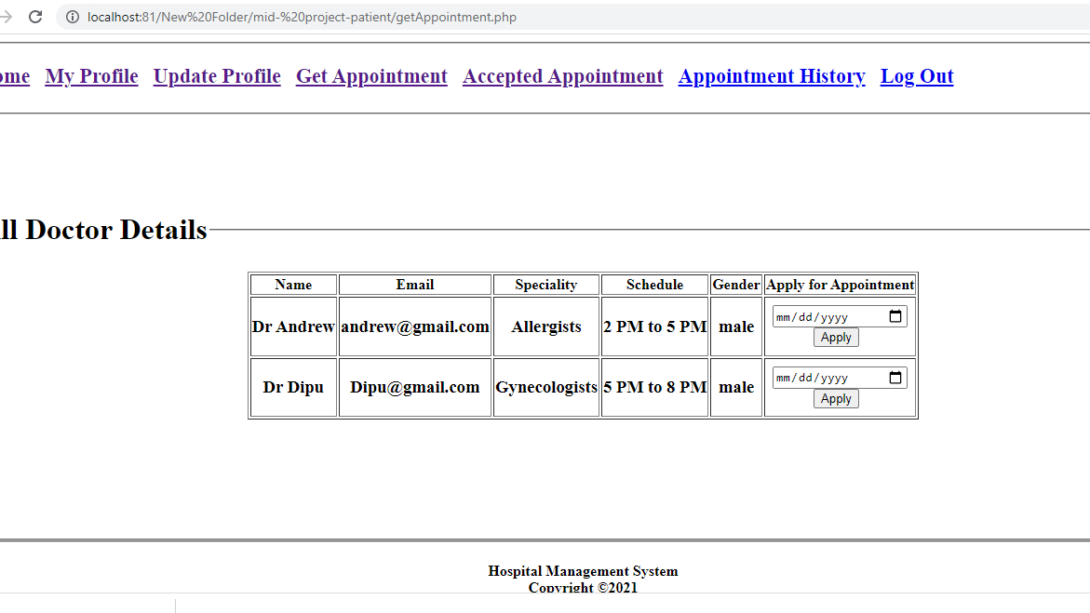

**4. Staff:**

**Impact of this Project:**

This project will be very useful to our modern society and people. People though who have a n internet connection only, can use this service installed in a health organization sector. They can see doctors schedule, get the appointment, check medical test expenditure at home. So, they can avoid disgusting traffic jam, doctor’s serial hassle & unwanted time spend. People will able to get hassle free medical services.

**Limitations and Possible Future Improvements:**

This is a sample demo project. This is not for commercial use. To use this service for real world organization features and service should be more detailed, enriched and easy accessible.

|  |  |  |  |  |  |
| --- | --- | --- | --- | --- | --- |
| CO1.1 and CO2.1Evaluation: Project Report Evaluation | | | | | |
| Project Proposal  (5) | Background  Study  (5) | Requirement Analysis  (5) | Entity  Diagram  (5) | System Images  against the  Specification (5) | Total (25) |
|  |  |  |  |  |  |
|  | | | | | |